1052 Console Printer

- Console Output Printer for System/360
- Cut-down Selectric I/O printer
  - No backspace
  - No tab
- Keyboard input was provided by a separate keyboard not attached directly to the printer, but to the CPU

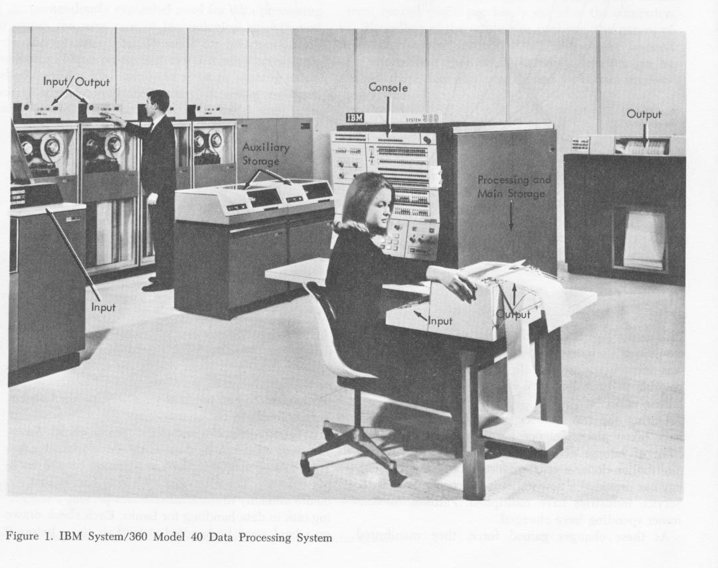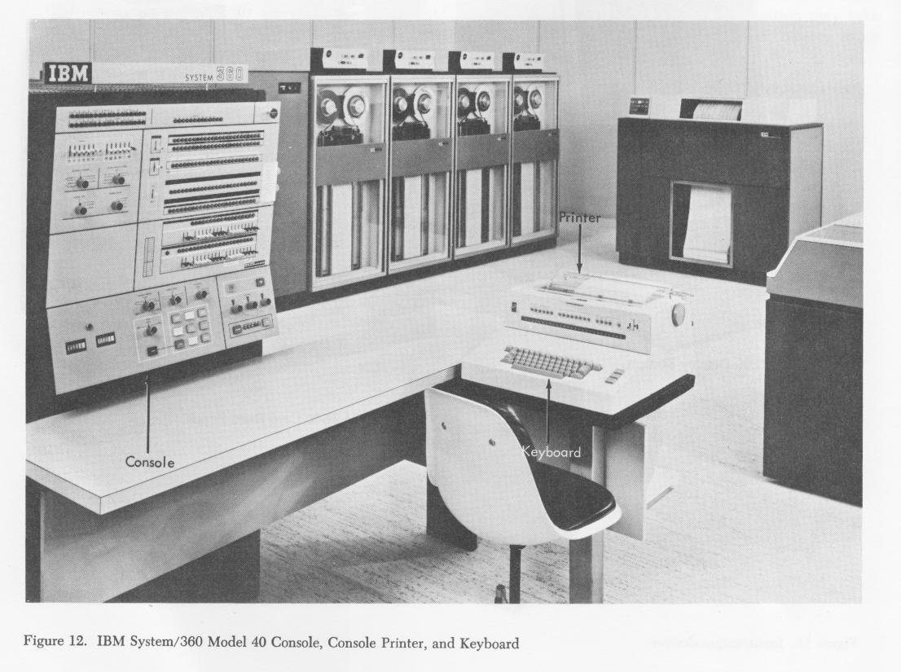

Photos extracted from IBM Textbook C20-1684 - S/360 Model 40 (developed in Hursley)

Selectric Golfball Operation

The golf ball print head contains 88 printable characters arranged in two hemispheres, the lower and upper case sides. The arrow on the print head points to the centre of the lower case side, the default position. To print upper case characters, the print head is first rotated through 180 degrees by the shift arm at the right hand end.

There are 4 rows of 11 characters on each half. The row is selected by tilting the print head. Tilt 0 is the home position, then tilt 1, 2 and 3 respectively.

To select the character to be printed, the print head must be rotated simultaneously to one of the 11 positions, from minus 5 through zero, the home position, to plus 5.
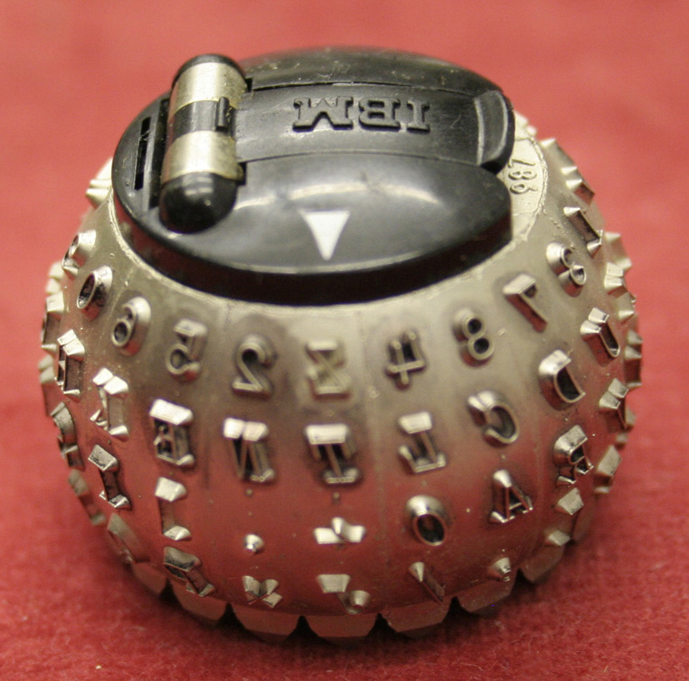

Note: This is a special programming golf ball. The lower case letters are in fact italic upper case. The upper case side contains special characters used in the APL programming language.

The golf ball is easily swapped, allowing changes in font, style and character set.

1052 Console Printer

Tilt / Rotate Selection

Electro-magnets are used to set up the mechanical parts to tilt and rotate to a specific character on the type head. There are two for the Tilt function and four for Rotate.

If none of the magnets are energised when printing, the golf ball will tilt 3 and rotate minus 5. To select tilt 0, both T1 and T2 magnets are energised. If T1 is energised by itself, tilt 2 is selected (tilt 3 minus 1). T2 by itself produces tilt 1.

Energising the R5 magnet produces a rotate zero. To print negative rotate characters, the R5 is not selected, whilst R1, R2 and R2a are used to increment from -5 to -1. For example, rotate -4 uses R1 alone, rotate -3 is R2, rotate -2 is R2 and R1, rotate -1 is R2 & R2a. Similarly, R5 in conjunction with R1, R2 and R2a produce positive rotate increments.

Using the Demonstration

The rotary switch is used to select which function you want to see. Do not press Go while operating this switch.
- Selecting print, you can set up tilt / rotate combinations then press Go.
- Select Space then press Go to space the carriage forwards.
- Select Return and press Go once to send the carriage back to the left.
- Select Shift, move the shift switch to Up or Down then press Go to see the shift function working.

